Rouse Global Patent Brochure

Table of Contents

Introduction 2
Approach 2
Value Proposition 2
Practice Areas 3
Why Rouse 4
People 4
Structure 5
Delivery 5
Contact Us 6

Global Patent Brochure

Introduction

We represent clients from start-ups to Fortune 500 companies and focus on serving technology companies seeking long-term, value-added relationships with us.

Approach

With over 100 patent professionals across our offices representing all major technical disciplines we write, file, prosecute and litigate designs and patents in Asia, Europe, Middle East, and Africa.

Above all, we are proven specialists who draw upon our first-hand experience spanning diverse industries, patent offices, R&D and academia to deliver quality, accuracy, and a meticulous level of detail in our work.

We enjoy the details of patenting an invention as much as inventors enjoy the details of their creations and we offer multidimensional perspectives by incorporating learnings from patent litigation in prosecution and vice versa. Our experience in advancing thousands of patents to issuance guides us when evaluating them for licensing negotiations and litigation. Likewise, having handled numerous license programmes and litigations, we have harvested keen insights into prosecution strategies which make for effective patents. Our extensive geographic reach enables us to adapt patent drafting styles to meet patent offices’ requirements and enhance the prosecution of applications worldwide.

Value Proposition

Our Value Proposition combines a high level of proximity to inventors with proven experience in prosecuting and managing design and patent portfolios internationally.

Input process Innovation Value Chain Output Outcome

To deliver our Value Proposition, we provide a full range of services throughout the life cycle of designs and patents, including prosecution, litigation and transactions.

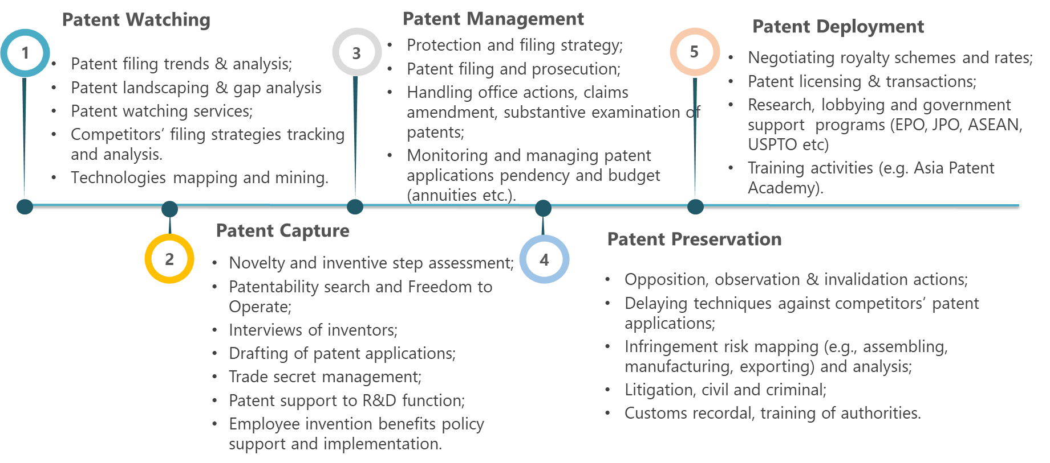

By engaging our firm, you will be supported throughout the life cycle of your innovations, from preliminary search up to enforcement and commercialisation, with specialists at every level.

Practice Areas

We cover the following 7 technological fields with assigned technology experts and team leaders overseeing each field.

By engaging our firm, you will be working with a multiple award-winning group of patent professionals who have earned a reputation as the go-to team for innovators in all major technical fields seeking protection of their inventions.

Why Rouse

The Rouse difference is embedded in our people, structure and work delivery articulated around our strong patent culture.

Culture

People

Every office has a team of patent professionals fully integrated into our Global Patent Group.
The synergies created through our worldwide offices are directly passed on to our clients through our Technology and Geographical hubs which integrate all patent team members to work with a consistent level of quality and care.

We support our people to access the best training and resources to meet the growing complex needs of our clients whilst helping them develop their skills and achieve their career ambitions. Many of our patent agents started their careers with us as technology specialists or engineers. We turn the finest technical minds into the finest legal minds.
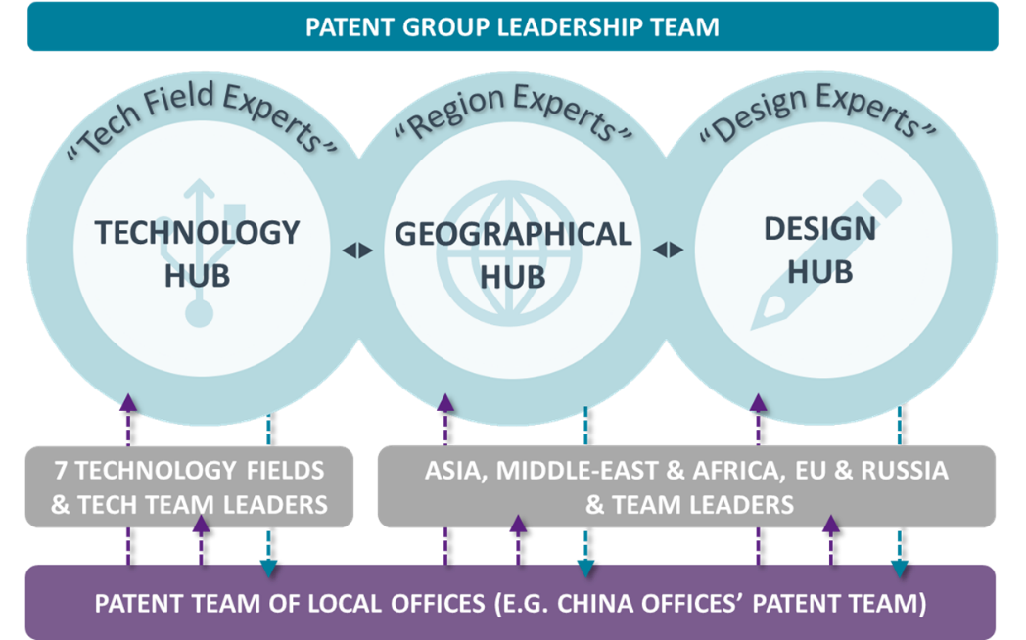

Structure

Our patent specialists have a wealth of expertise and experience in navigating the complexity of global patent prosecution rules. Through our hubs we provide flexible support to meet individual client’s needs in accordance with their own organisation and the issues they face.

The geographical hub handles regional filing programmes to deliver quality and financially competitive prosecution services. The technologies hub provides technologies and complex patent support and has been developed to access Rouse’s best technology experts.

 | Geographical hub | Technologies hub
Team members | Team of senior paralegals across our offices. | Team of technology specialists and patent agents.
Scope | Asia, Europe, Middle East & Africa. | All seven technical fields mentioned above.
About you | Clients with in-house patent capabilities who are primarily interested in streamlined regional filing programmes with specific prosecution goals and financial requirements to achieve. | Clients who need support in making critical decisions with confidence and the full understanding of the value of their innovations.
Fees type | Fixed fees. | Capped fees and/or hourly fees.
Examples of work | Managing regional patent portfolio; nationalizing PCT applications across multiple jurisdictions; patent searches and watching services; payment of annuities etc. | Interviews with inventors; drafting applications, claims amendments; strategizing filing routes; Freedom to Operate, patent mapping etc.

By engaging our firm, you will be offered the choice between different options to manage your innovations. You could draw on our technical expertise, our regional prosecution skills, or both to help you achieve your business objectives.

Delivery

We have adopted innovative approaches to our service delivery model by streamlining prosecution work, customising reports and smart invoicing to best meet clients’ needs.
We use internal and external digital solutions to support the delivery of our services. For example, we have created Patempo™ (www.patempo.com) which allow applicants to automatically estimate the pendency of their design and patent applications in Asia and evaluate means to expedite their examination and grant.

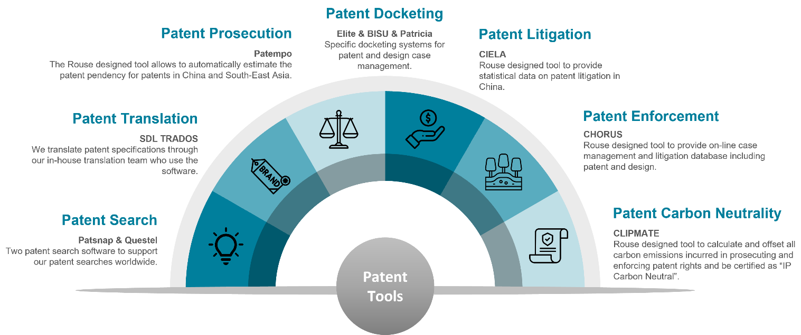

By engaging our firm, you will receive state of the art service delivery supported by digital tools to help you oversee your portfolios effortlessly.

Contact Us

Fabrice Mattei
Principal and Global Head of Patent Group

T: +66 2 653 2730
MP: + 668 1 66 56 444
E: fmattei@rouse.com

